POWER
Install battery before use.
1. Turn flashlight lens endcap counterclockwise to open battery slot.
2. Insert LI-Ion battery into battery slot with + terminal end first.
3. Re-attach flashlights lens endcap by turning clockwise. Do not cross threads. Do not overtighten.
4. For optimal performance, charge fully before first use.

LIGHT SETTING AND BRIGHTNESS
Rotate light selector knob in either direction to cycle through 8 settings.

BATTERY LEVEL INDICATOR (BLI)
Battery level Indicator (BLI) is located inside the lens, under the light selector knob.
- When powering off, BLI light will quickly flash indicating remaining battery power.
- When rotating light selecter knob, if Light Stick doesn’t turn on or BLI light flashes red then off, battery power is too low and must be recharged.

Operating instructions: see charts.

Bonus Candle Modus: Chart shows order when turned clockwise. Order reverses when turned counterclockwise.
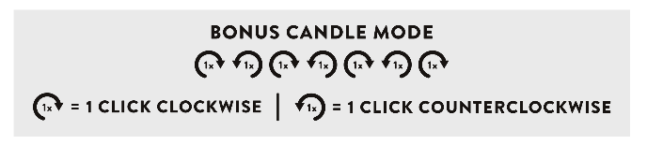

CHARGING INSTRUCTIONS
With Li-Ion battery installed, plug USB-C charging cable into Light Stick’s USB-C port and other end into external power source to begin charging. BLI light will fade on and off at various speeds indicating that power is being distributed to battery

POWER OUTPUT
Edison Light Stick is capable of power output via USB-C Port.
- Plug one end of the USB-C cable into Edison Light Stick and other end into external device.
- Edison Light Stick will automatically distribute power when external device is plugged in.
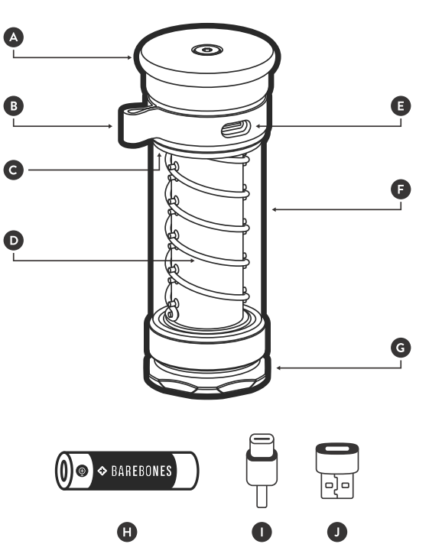
TECHNICAL SPECIFICATIONS

USE AND MAINTENANCE
Your Light Stick is weatherproof under normal conditions of use. Dry/wipe the Light Stick with a soft microfiber cloth. Do not disassemble the Light Stick. Doing so may damage the Light Stick and void the guarantee. Use only a Barebones battery LIV-903.

COMPONENTS
A Light Selector Knob F Lens
B Leather Strap & Hang Loop G Flashlight Lens Endcap
C Battery Level Indicator H Li-Ion Battery 18650 (Barebones specific)
D LED Rope I USB-C to USB-C Cable (included)
E USB-C Port J USB-C to USB-A Adapter (included)

SAFETY INSTRUCTION
- This product is not intended for use by children.
- Do not look directly into the light.
- Do not submerge the light in liquid. Rotate the leather strap to block water and dust access to the USB-C port.
- Do not use or charge the lights in temperatures below 0ºC or 45ºC
- The warnings, cautions and instructions in this manual cannot cover all possible conditions or situation that culd occur. Exercise common sence and caution when using this product.

ENVIRONMENTALLY FRIENDLY WASTE DISPOSAL
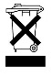
Recycling - European Directive 2012-19/EU. This marking indicates that this product must not be disposed of with other household waste. In order not to endanger the environment and human health and to promote the recycling of resources, this product must be disposed of responsibly. Please hand in the used product at the designated collection points for electronic waste.

COMPLIANCE AND CERTIFICATES

WARRANTY
Barebones Living LCC provides a 2-year warranty on all defects resulting from hidden faults and which make the product unsuitable for normal use. The warranty takes effect at the time of purchase; please keep the receipt carefully.

SERVICE
For more information, please see: www.barebonesliving.eu or email: service@barebonesliving.eu

